Aroonav Pradhan

Professor Grigoriy Grinberg

CMSC 203

02/19/20

Assignment 2 Implementation

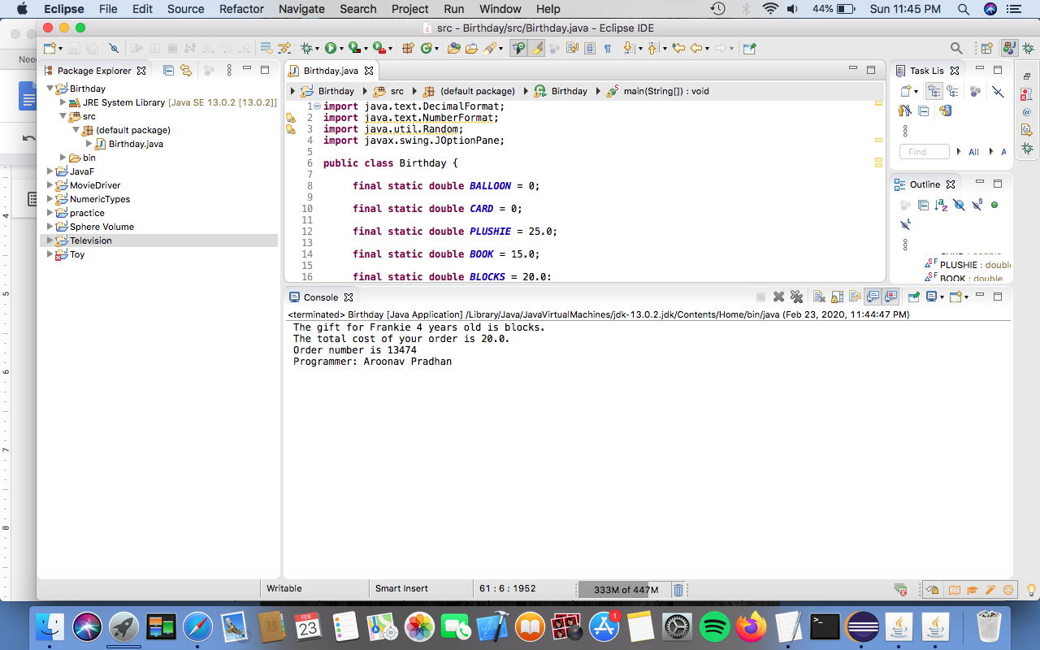

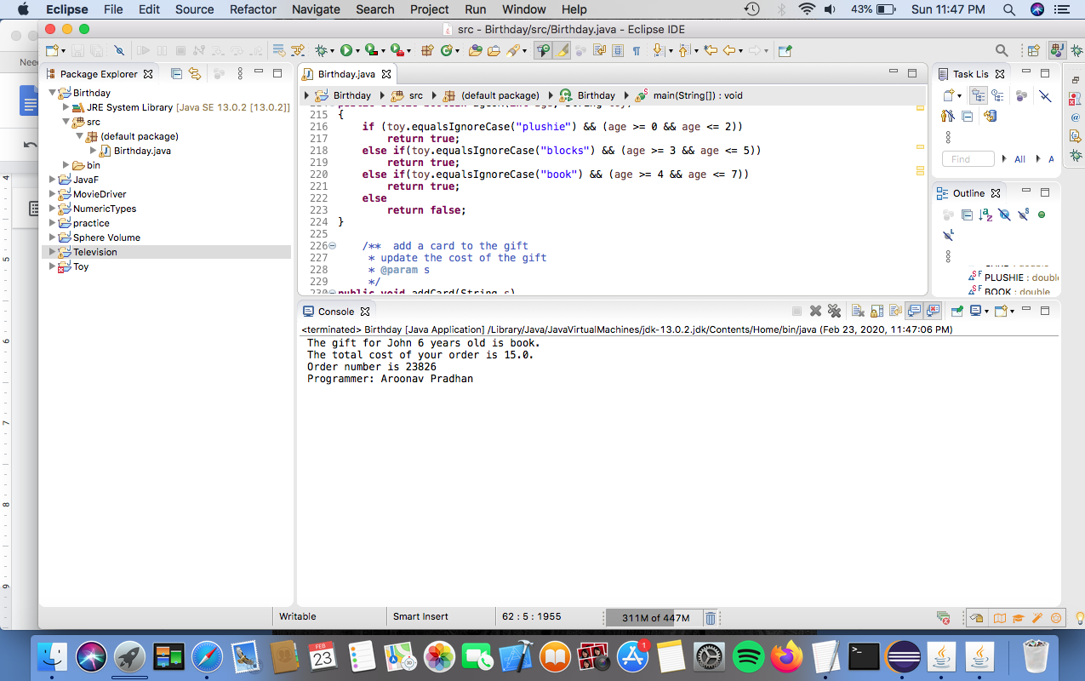

Lesson Learned

This assignment was very challenging because it required us to know a lot of key components to building a slightly complex program. I was able to master some important topics during this assignment. From next time onwards I will plan out my code properly before typing it into the program.